**Omshree R Hiremath**

**Employee Code: 655127**

**DBMS Day-3**

**AZURE SQL**

# Creating SQL Server-

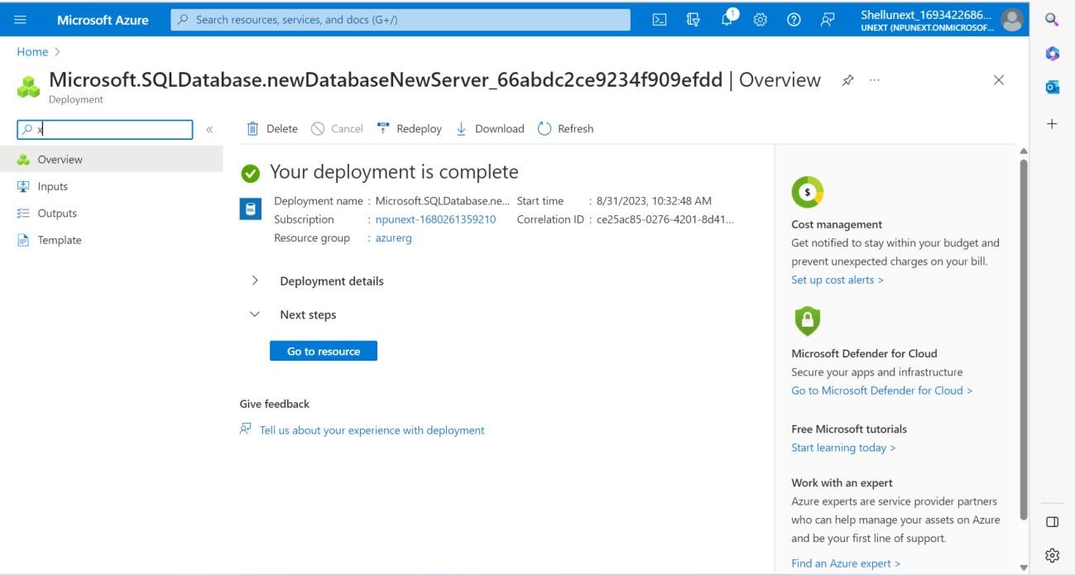

# Creating SQL Database-

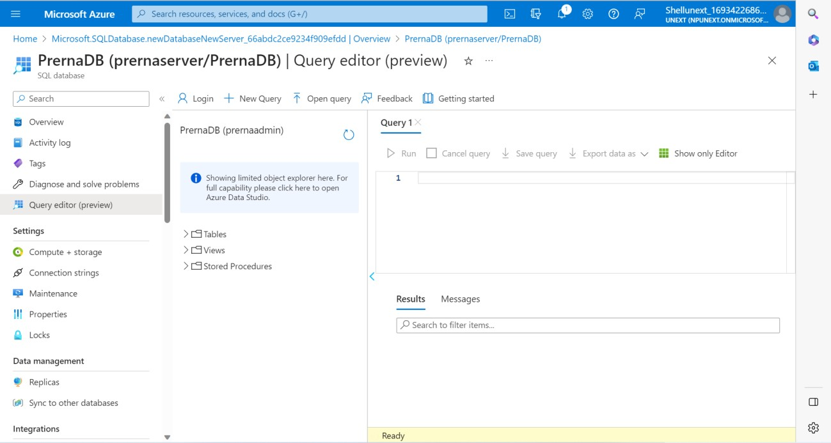

# Performing Queries-

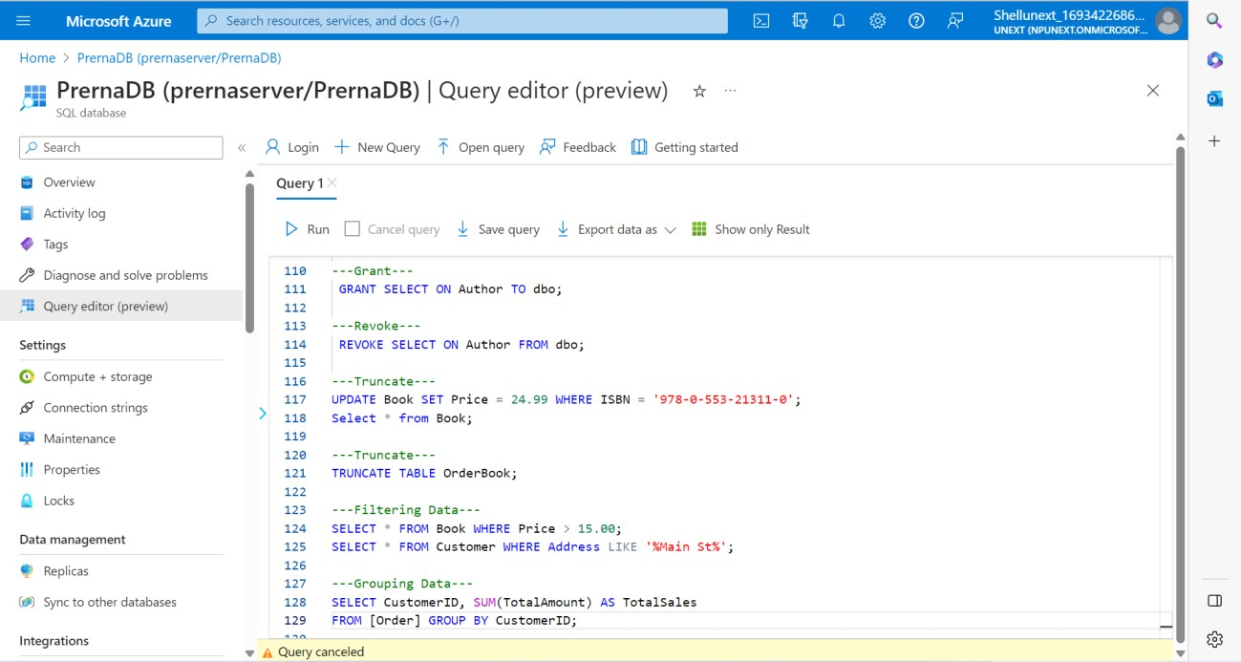

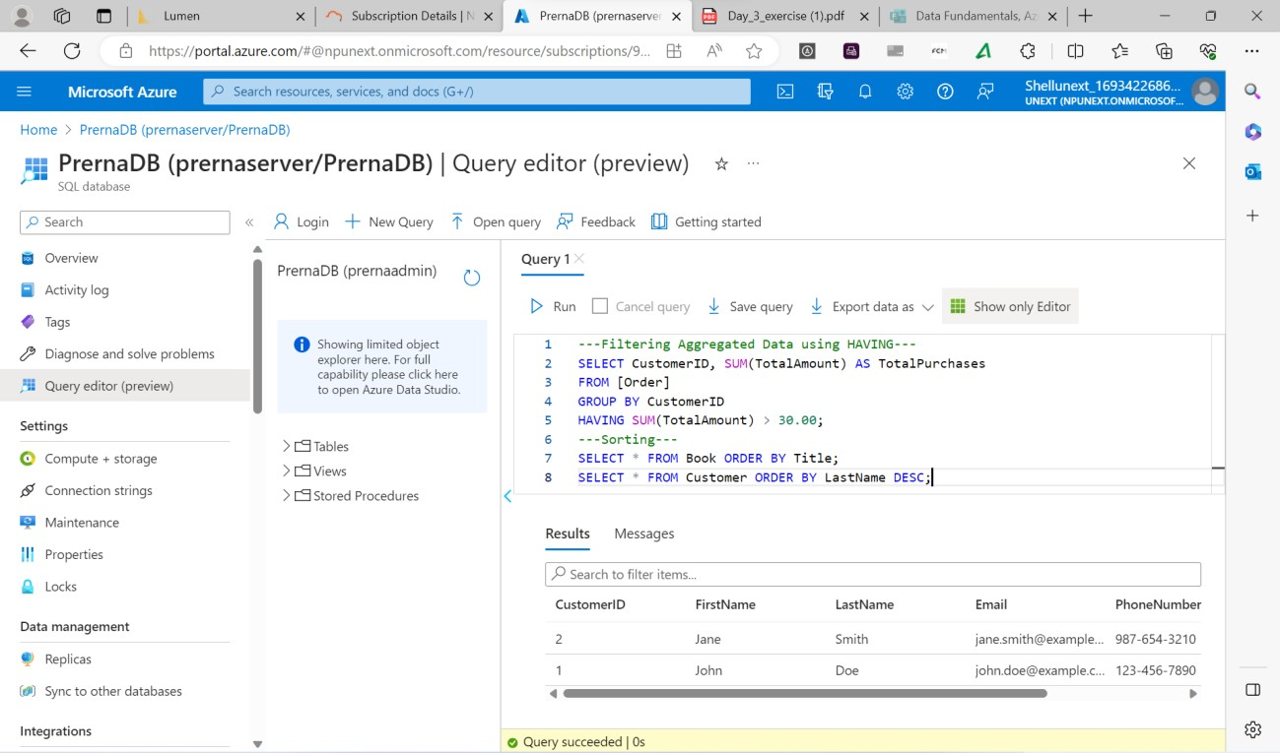

# Exercise- 1)

CREATE TABLE DEPARTMENT(

DeptID INT PRIMARY KEY,

DeptName VARCHAR(30),

DeptCode VARCHAR(10)

);

DROP TABLE EMPLOYEE;

CREATE TABLE EMPLOYEE(

EmpID INT PRIMARY KEY,

EmpName VARCHAR(30) NOT NULL,

EmailID VARCHAR(20),

DeptID INT,

FOREIGN KEY(DeptID) REFERENCES DEPARTMENT(DeptID)

);

# 2)

CREATE TABLE DEPARTMENT(

DeptID INT PRIMARY KEY,

DeptName VARCHAR(30),

DeptCode VARCHAR(10)

);

DROP TABLE EMPLOYEE;

CREATE TABLE EMPLOYEE(

EmpID INT PRIMARY KEY,

EmpName VARCHAR(30) NOT NULL,

EmailID VARCHAR(20),

DeptID INT,

FOREIGN KEY(DeptID) REFERENCES DEPARTMENT(DeptID)

);

INSERT INTO DEPARTMENT VALUES (1001,'INFO, DATA AND ANALYTICS','IDA');

INSERT INTO DEPARTMENT VALUES (1002,'TRANSFORMATION CHANGE ANALYST','TCA'); INSERT INTO DEPARTMENT VALUES (1003,'BUSINESS ANALYSIS','BA');

INSERT INTO [dbo].[EMPLOYEE] VALUES (1,'PRERNA','PRERNA@XYZ.COM','1001');

INSERT INTO [dbo].[EMPLOYEE] VALUES (1,'OMSHREE','OM@XYZ.COM','1001');

INSERT INTO [dbo].[EMPLOYEE] VALUES (1,'PRAKET','PRAK@XYZ.COM','1002');

INSERT INTO [dbo].[EMPLOYEE] VALUES (1,'SIDDHARTH','SID@XYZ.COM','1002');

INSERT INTO [dbo].[EMPLOYEE] VALUES (1,'SAKETH','SAKETH@XYZ.COM','1003');

INSERT INTO [dbo].[EMPLOYEE] VALUES (1,'SANJANA','SANJ@XYZ.COM','1003');

CREATE TABLE STUDENTS(

SLNO INT PRIMARY KEY,

ID INT,

SNAME VARCHAR(20),

SSUBJECT VARCHAR(20),

MARKS INT);

INSERT INTO STUDENTS VALUES(1,5030,'ASHLEY','DWH',50);

INSERT INTO STUDENTS VALUES(2,5031,'PRIYA','DWH',61);

INSERT INTO STUDENTS VALUES(3,5032,'JULIA','DWH',90);

INSERT INTO STUDENTS VALUES(4,5033,'DON','DWH',50);

INSERT INTO STUDENTS VALUES(5,5034,'BOB','DWH',65);

INSERT INTO STUDENTS VALUES(6,5030,'ASHLEY','SQL',75);

INSERT INTO STUDENTS VALUES(7,5031,'PRIYA','SQL',80);

INSERT INTO STUDENTS VALUES(8,5032,'JULIA','SQL',40);

INSERT INTO STUDENTS VALUES(9,5033,'DON','SQL',88);

INSERT INTO STUDENTS VALUES(10,5034,'BOB','SQL',92);

INSERT INTO STUDENTS VALUES(11,5030,'ASHLEY','AZURE',95);

INSERT INTO STUDENTS VALUES(12,5031,'PRIYA','AZURE',45);

INSERT INTO STUDENTS VALUES(13,5032,'JULIA','AZURE',85);

INSERT INTO STUDENTS VALUES(14,5033,'DON','AZURE',57);

INSERT INTO STUDENTS VALUES(15,5034,'BOB','AZURE',44);

SELECT * FROM STUDENTS;

# --- Query 1 ---

select s1.s_name, s1.s_subject, s1.s_marks from students s1 join

(select s_subject, max(s_marks) as max_marks from students group by s_subject) s2 on (s1.s_subject = s2.s_subject and s1.s_marks = max_marks);

--- OR ---

with cte as (select dense_rank() over (partition by s_subject order by s_marks desc) xyz, s_subje ct, s_marks, s_name from students)

select * from cte where xyz = 1;

**--- Query 2 ---**

select * from students order by s_subject asc, s_marks desc;

**--- Query 3 ---**

select * from students where s_marks<50;

**--- Query 4 ---**

select * from students where s_subject = 'Azure' order by s_marks desc;

**--- Query 5 ---**

select s_name, sum(s_marks) from students group by s_name;

**--- Query 6 ---**

select s_name, sum(s_marks) from students group by s_name order by sum(s_marks);

**--- Query 7 ---**

select s_subject, sum(s_marks) from students group by s_subject order by sum(s_marks);

# --- Query 8 ---

with cte as (select dense_rank() over (partition by s_subject order by s_marks desc) xyz, s_subje ct, s_marks, s_name from students)

select * from cte where xyz = 2;

# --- Query 9 ---

select s1.s_name, s1.s_subject, s1.s_marks, s2.max_marks from students s1 join

(select s_subject, max(s_marks) as max_marks from students group by s_subject) s2 on (s1.s_subject = s2.s_subject);

# --- Query 10 ---

select *, (left(s_name,3) + right(id,2) + '@ta.com') as email from students;